San Francisco State University
CSC 648 - 848
Milestone 0 Submission Form
Section 06 Team 1

Github repo name

SFSU-csc648-06-Fall26-team01
https://github.com/SFSU-CSC648-TeamOne/SFSU-csc648-06-Fall26-team01

Team About page name

https://frontend-phi-hazel-cmbz8sepjp.vercel.app/about/
https://frontend-team01-0e5b.vercel.app/

Underlying Technology

Below is a list of the technologies used in Team 01's software stack:
Cloud/Hosting Platform : Vercel
Database : Supabase
Front-end Framework : React/Next.js
Back-end Language : Python
Back-end Framework : FastAPI
Additional Technologies : Notion, Claude, ChatGpt, Gemini, Canva
IDE/Code Editor : Visual Studio Code
Version Control : Git/GitHub

How to access cloud/hosting platform

Item | Credentials
Website URL | https://frontend-team01-0e5b.vercel.app/
Cloud VM instance | N/A
Database URL | db.fapktwxbhoohkvbzmjgl.supabase.co

Team 01’s Source Code Repository Access

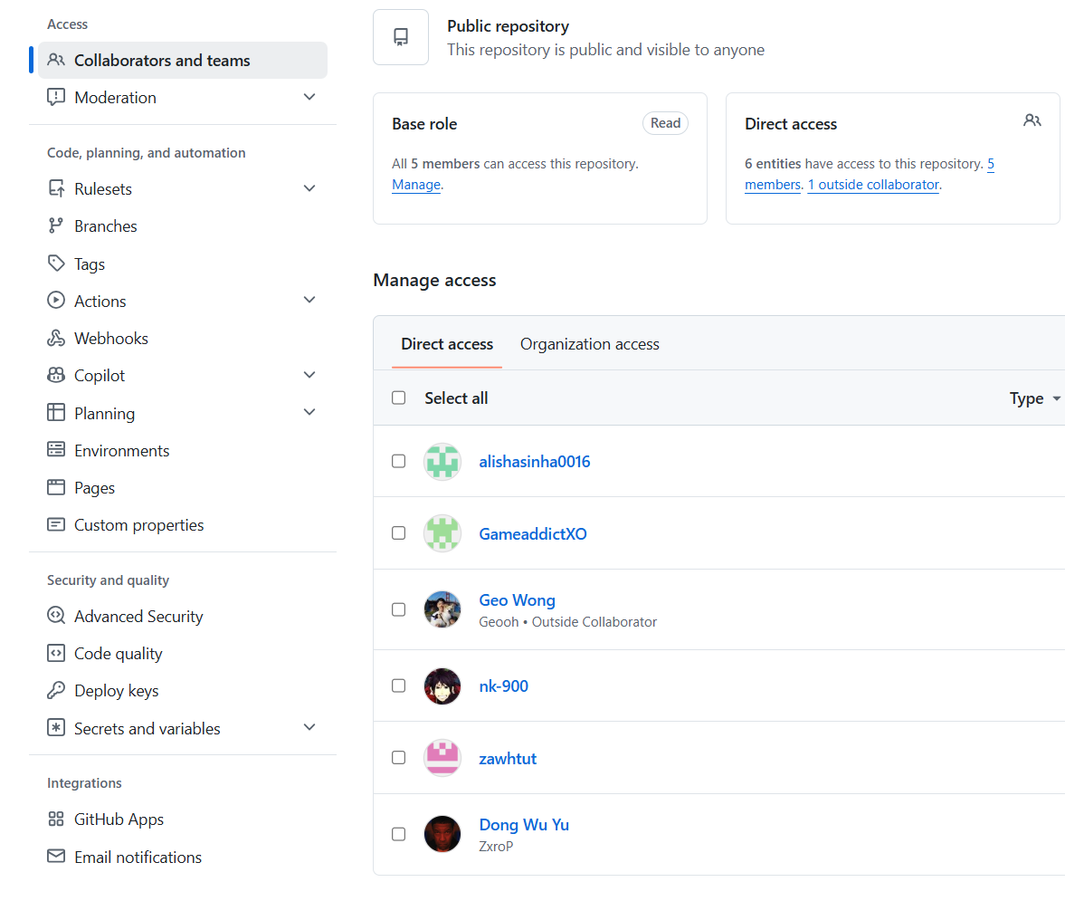

Database Members’ access and invitations

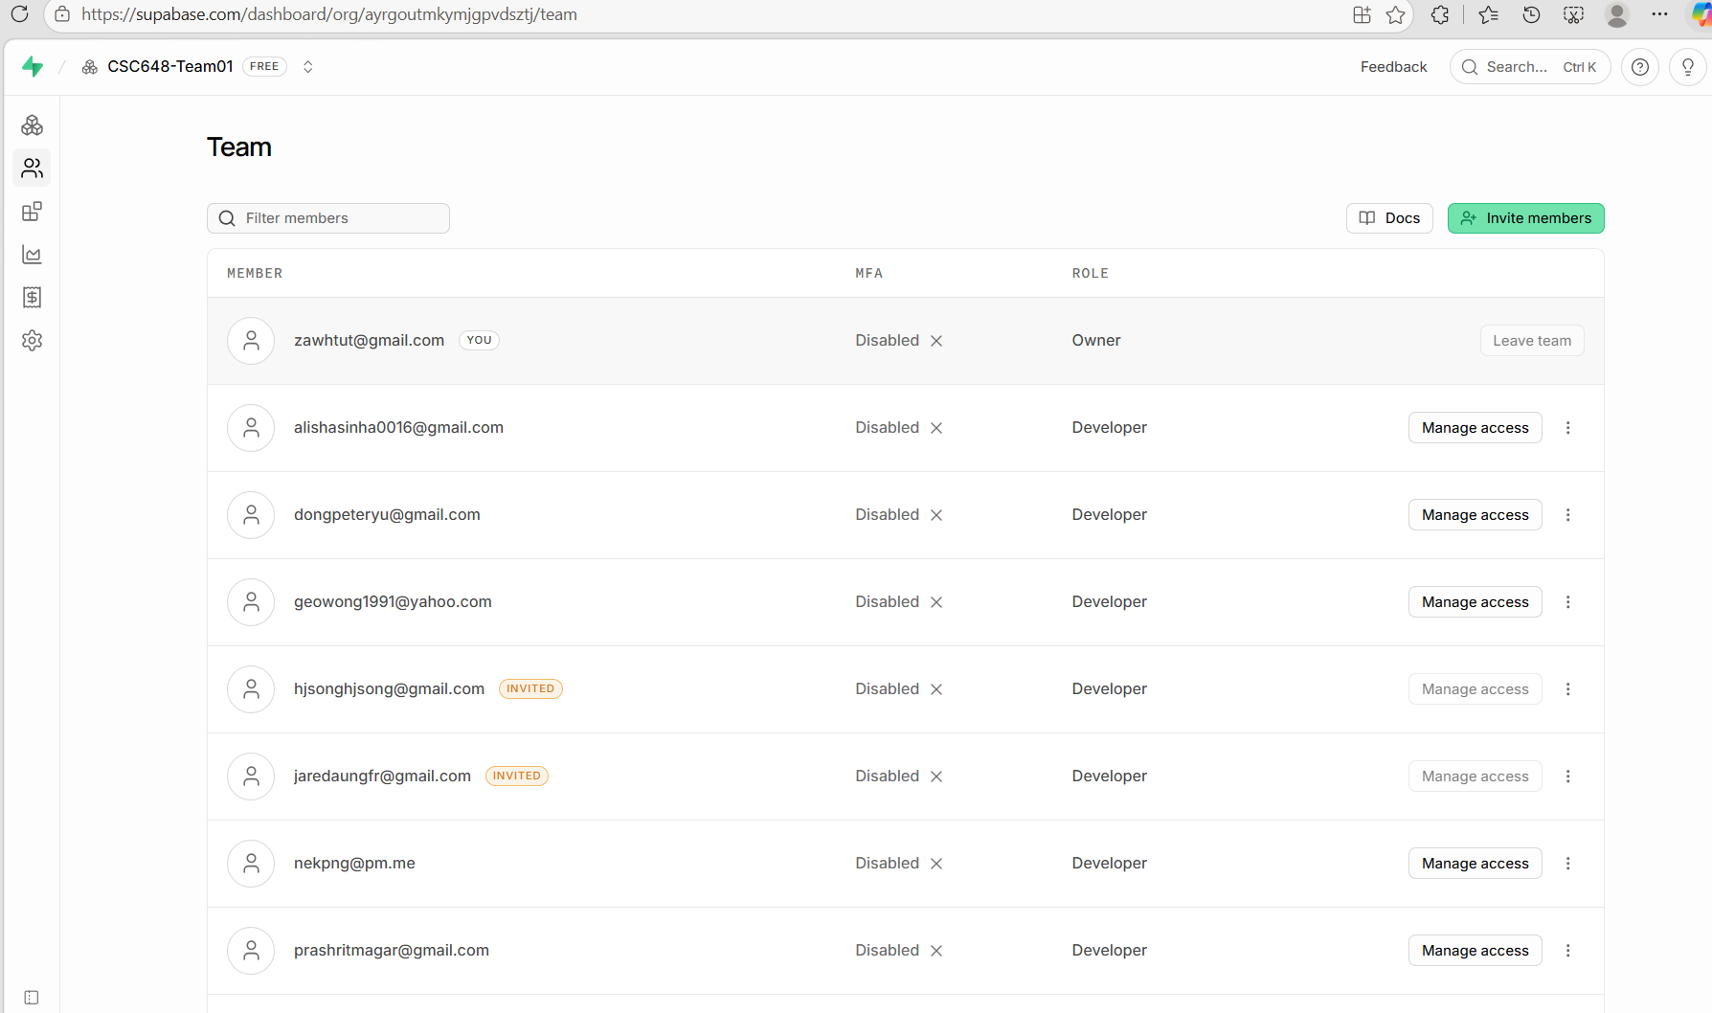

Database Schema Visualizer

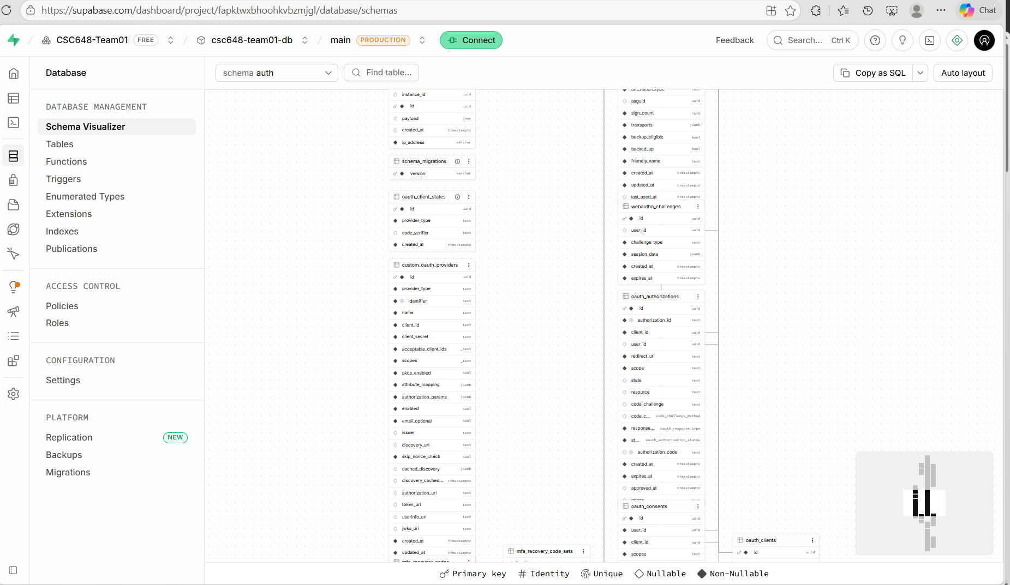
Study Plan

Team 01’s study plan for each technology
 | Vercel | JS/  Next.js | React | Python/  FastAPI | Supabase/  Postgres | Git
Alisha | 1 | 2 | 2 | Python-3-4  FastAPI - 3 | 2 | 3
Dong | 1 | 5 | 5 | Python - 3  FastAPI-2 | 2 | 3
Geo | 1 | 3 | 3 | Python - 4  FastAPI-3 | 3 | 3
Ian | 1 | 2 | 2 | 1 | 2 | 3
Prashrit | 1 | 2 | 2 | 2 | 2 | 3
Zaw | 3 | 3 | 3 | 3 | 3 | 3

based on the scale of 5

Based on team member’s familiarity, we set up the following study plan.

Two patterns jump out: everyone is weak on Vercel (mostly 1/5), and Ian/Prashrit are behind across the board and will need more pairing time than the rest of the team.
Study Assignments by Technology(Currently we have plan for the next 4-6 weeks)
1. Next.js / React (Frontend)
• Lead: Dong (Frontend Lead, React 5/5)
• Also studying: Alisha, Ian, Prashrit (all around 2/5) — Geo (Backend Lead) is pitching in too, per the original plan
• 4-week goal: Login page, plus 5 pages — workout plans, user category, saved plans, meal plans, AI chatbot page
 | Week 1 | Week 2 | Week 3 | Week 4
Focus | Next.js/React basics  (components, hooks,  routing) —  Dong walks  the team through it | Build Login page +  navigation  shell | Build workout plans, user category,  saved plans pages | Build meal  plans + AI  chatbot page, polish  styling

2. Python / FastAPI (Backend)
• Lead: Geo (Backend Lead, Python 4/5, FastAPI 3/5)
• Also studying: Alisha (already solid at 3/3), Dong, Ian, Prashrit (need the most ramp-up here)
• Note: Prashrit is our AI Master — as he ramps up on FastAPI, have him focus specifically on the chatbot and ML-prediction endpoints so his role and his study time line up
• 4-week goal: Core API running — auth, plan CRUD endpoints, chatbot endpoint stub
 | Week 1 | Week 2 | Week 3 | Week 4
Focus | FastAPI  basics —  routes,  request/respo nse models, auto docs  (Swagger) | Build auth  endpoints,  connect to  Supabase/Post gres | Build CRUD  endpoints for workout/diet plans | Build chatbot endpoint  stub, connect to frontend

3. Supabase / PostgreSQL (Database)
• Lead: Geo
• Also studying: Zaw, Dong
• 4-week goal: Finalized schema, Supabase project wired up to the backend
 | Week 1 | Week 2 | Week 3 | Week 4
Focus | Learn  Supabase  basics —  auth, tables, row-level  security | Design schema (users,  plans, logs) | Connect  FastAPI  backend to  Supabase via ORM | Test queries end-to-end, handle edge cases

4. Vercel (Deployment)
• This is our biggest team-wide gap — everyone is at 1/5 except Zaw (3/5) • Lead: Zaw (GitHub Master) runs a workshop for the whole team • 4-week goal: Everyone can deploy and read build logs without help
 | Week 1 | Week 2 | Week 3 | Week 4
Focus | Zaw-led  workshop:  connecting  the GitHub  repo, env  variables,  preview  deployments | Everyone  deploys their own  branch/previe w at least  once | Practice  debugging a failed build together as a team | Deployment  becomes  routine — no more hand  holding

5. Git (Team Workflow)
• Owner: Zaw (GitHub Master) — sets up branch protection, PR templates, and repo structure
• Everyone's already decent here (3/5 across the board), so this is a light touch, not a deep study item
• 4-week goal: One agreed-on branching + PR workflow that actually gets followed
 | Week 1 | Week 2 | Week 3 | Week 4
Focus | Agree on  branch  naming, PR  template,  commit style | Practice it on every PR | Keep  practicing it on every PR | Team retro — fix  whatever's  been annoying about the  workflow

Future Plans
- RAG
- LLM API Use
- Voice Agent (still debating)
- Data Analytics
- Niantic Spatial API (Researching)

A Few Notes
• Ian (Scrum Master): run a short weekly check-in against this plan, is each week's focus actually getting done, and does anything need to shift using Notion/Discord? Update Alisha about this during check in.

• Alisha (Product Manager): keep this study plan mapped against the overall project timeline so studying and building don't fall out of sync. Weekly check in with each team member on how everyone is doing.

• Pairing rule of thumb: put a stronger person with a weaker one on each task, rather than splitting by tech area alone.

• Zaw is the most well-rounded (3/5 everywhere) — good person to float between frontend/backend/deployment wherever the team gets stuck that week.

• Since Vercel is everyone's weakest spot, it's worth doing that workshop in Week 1 before anyone tries to deploy anything on their own.

